Heat map of MLJ IT landscape with transition priorities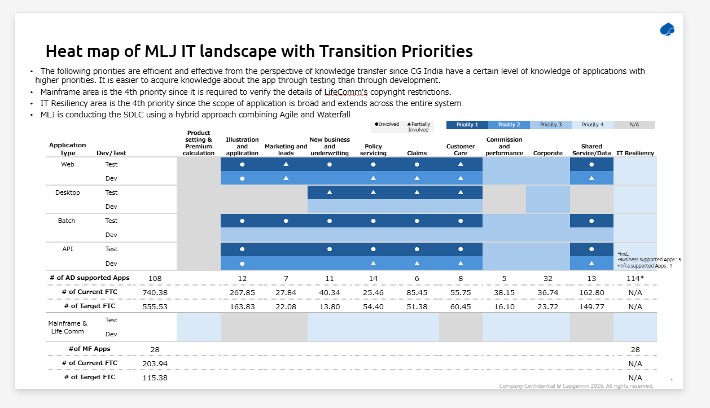

Overview of MLJ Application landscape
